**CHAPTER 1**

**INTRODUCTION**

**PROJECT OVERVIEW**

The online car rental management system is web based software to provide users for renting a car from online rental system. This project also keeps details of the users and their reserved information. It is maintained by a single administrator. He can add or remove cars in database. To reserve a car user must register and reserve a car.

This document is intended to minimize human works and make car reservation an easier job for users and rental company by providing online application for Users, automatically select the car from the list and pay price. Users can view list of cars, previous bookings and their price by login into the online system.

**PROJECT OBJECTIVES**

* Allow Users to reserve a Car.
* Admin can send the approval notification to every approved student via email.
* Automatically insert user’s details to the reservation record when user reserved a car
* Admin can add Cars.
* Users can view prices of cars, they want to reserve
* Users can cancel their reservation

**CHAPTER 2**

**SYSTEM ANALYSIS**

**EXISTING SYSTEM**

The existing system is manual based and need lot of efforts and consume enough time. In the existing system we can apply for the hostels online but the allotment processes are done manually. It may lead to corruptions in the allocation process as well as hostel fee calculation. The existing system does not deals with mess calculation and complaint registration.

**DISADVANTAGES:**

• More human power

• More strength and strain of manual labour needed

• Repetition of same procedure.

• Low security.

• Data redundancy.

• Difficulty to handle.

• Difficulty to update data. Record keeping is difficult.

• Backup data can be easily generated.

**PROPOSED SYSYTEM**

The proposed system is having many advantages over the existing system. It require less overhead and very efficient. The proposed system deals with the mess calculation and allotment process efficiently.

**CHAPTER 3**

**FEASIBILITY STUDY**

**TECHNICAL FEASIBILITY**

The technical feasibility in the proposed system deals with the technology used in the system. It deals with the hardware and software used in the system whether they are of latest technology or not. It happens that after a system is prepared a new technology arises and the user wants the system based on that technology. This system use windows platform, .net as front end technology and sql server as backend technology. Thus ONLINE Car Rental Management

SYSTEM is technically feasible.

**ECONOMICAL FEASIBILITY**

Economic analysis is the most frequently used method for evaluating the effectiveness of a new system. More commonly known as cost/benefit analysis. .net using visual C# and sql datdabase easily available in internet

**OPERATIONAL FEASIBILITY**

The project has been developed in such a way that it becomes very easy even for a person with little computer knowledge to operate it. This software is very user friendly and does not require any technical person to operate .Thus the project is even operationally feasible.

**CHAPTER 4**

**REQUIREMENT ANALYSIS AND SPECIFICATION**

Functions and features delivered to the end users

The end users of the proposed system are:

**Administrator module:**

In administrator module administrator manages the master data’s like server details and car details. Accept the reservation of users, view the reservation forms, reject the fake reservations,

**User Module:**

In User module, they can submit reservation form, change password, can check reservations, view car details, view car price and submit the reservation form.

**HARDWARE CONFIGURATION**

The section of hardware configuration is an important task related to the software development insufficient random-access memory may affect adversely on the speed and efficiency of the entire system. The process should be powerful to handle the entire operations. The hard disk should have sufficient capacity to store the file and application.

Processor : Pentium IV and above

Processor speed : 1.4 GHz Onwards

System memory : 128 Mb minimum 256 Mb recommended

Cache size : 512 KB

RAM : 512 MB(Minimum)

Network card : Any card can provide a 100mbps speed

Network connection : UTP or Coaxial cable connection

Printer : Inkjet/Laser Colour printer provides at least 1000

Hard disk : 80Gb

Monitor : SVGA Colour 15”

Mouse : 104 keys US Key Serial, USB or PS/2

Modem : 56.6 Kbps

**SOFTWARE CONFIGURATION**

A major element in building a system is the section of compatible software since the software in the market is experiencing in geometric progression. Selected software should be acceptable by the firm and one user as well as it should be feasible for the system.

This document gives a detailed description of the software requirement specification. The study of requirement specification is focused specially on the functioning of the system. It allow the developer or analyst to understand the system, function to be carried out the performance level to be obtained and corresponding interfaces to be established.

Front end tool: PHP language

Backend : MY Sql

Operating system : Windows 2007/2008

Client Side : HTML

**2.3 Software Features**

**PHP TRIAD**

PHPTriad installs a complete working PHP/MySQL server environment on Windows platforms (9x/NT). Installs PHP, MySQL, Apache, and PHPMyAdmin.

**PHP**

PHP is a scripting language originally designed for producing dynamic web pages. It has evolved to include a command line interface capability and can be used in standalone graphical applications. While PHP was originally created by Rasmus Lerdorf in 1995, the main implementation of PHP is now produced by The PHP Group and serves as the de facto standard for PHP as there is no formal specification. PHP is free software released under the PHP License, however it is the usage of the term PHP. It is a widely-used general-purpose scripting language that is especially suited for web development and can be embedded into HTML. It generally runs on a webserver, taking PHP code as its input and creating web pages as output. It can be deployed on most web servers and on almost every operating system and platform free of charge. PHP is installed on more than 20 million websites and 1 million web servers.

PHP originally stood for Personal Home Page. It began in 1994 as a set of Common Gateway Interface binaries written in the C programming language by the Danish/Greenlandic programmer Rasmus Lerdorf.

Lerdorf initially created these Personal Home Page Tools to replace a small set of Perl scripts he had been using to maintain his personal homepage. The tools were used to perform tasks such as displaying his résumé

and recording how much traffic his page was incompatible with the GNU General Public License (GPL), due to restrictions on receiving. He combined these binaries with his Form Interpreter to create PHP/FI, which had more functionality. PHP/FI included a larger implementation for the C programming language and could communicate with databases, enabling the building of simple, dynamic web applications.

Lerdorf released PHP publicly on June 8, 1995 to accelerate bug location and improve the code. This release was named PHP version 2 and already had the basic functionality that PHP has today. This included

Perl-like variables, form handling, and the ability to embed HTML. The syntax was similar to Perl but was more limited, simpler, and less consistent.

Zeev Suraski and Andi Gutmans, two Israeli developers at the

Technion IIT, rewrote the parser in 1997 and formed the base of PHP 3, changing the language’s name to the recursive initialism PHP: Hypertext Pre-processor. The development team officially released PHP/FI 2 in

November 1997 after months of beta testing. Afterwards, public testing of PHP 3 began, and the official launch came in June 1998. Suraski and Gutmans then started a new rewrite of PHP’s core, producing the Zend

Engine in 1999. They also founded Zend Technologies in Ramat Gan, Israel.

On May 22, 2000, PHP 4, powered by the Zend Engine 1.0, was released. On July 13, 2004, PHP 5 was released, powered by the new Zend Engine II. PHP 5 included new features such as improved support for

and consistent interface for accessing databases), and numerous performance object-oriented programming, the PHP Data Objects extension (which defines a lightweight enhancement. The most recent update released

by The PHP Group is for the older PHP version 4 code branch.

In 2008, PHP 5 became the only stable version under development. Late static binding has been missing from PHP and will be added in version 5.3. PHP 6 is under development alongside PHP 5. Major changes include the removal of register_globals, magic quotes, and safe mode. The reason for the removals was because register_globals had given way to security holes, and magic quotes had an unpredictable nature, and was best avoided. Instead, to escape characters, Magic quotes may be substituted with the addslashes()

function, or more appropriately an escape mechanism specific to the database vendor itself like mysql_real_escape_string() for MySQL.

PHP does not have complete native support for Unicode or multibyte strings; Unicode support will be included in PHP 6. Many high profile open source projects ceased to support PHP 4 in new code as of February 5, 2008, due to the GoPHP5 initiative, provided by a consortium of PHP developers promoting the transition from PHP 4 to PHP 5. It runs in both 32-bit and 64-bit environments, but on Windows the only official distribution is 32-bit, requiring Windows 32-bit compatibility mode to be enabled while using IIS in a 64-bit Windows environment. There is a third-party distribution available for 64-bit Windows.

**Usage**

PHP is a general-purpose scripting language that is especially suited for web development. PHP generally runs on a web server, taking PHP code as its input and creating web pages as output. It can also be used for

command-line scripting and client-side GUI applications. PHP can be deployed on most web servers, many operating systems and platforms, and can be used with many relational database management systems. It is

available free of charge, and the PHP Group provides the complete source code for users to build, customize and extend for their own use.

PHP primarily acts as a filter, taking input from a file or stream containing text and/or PHP instructions and outputs another stream of data; most commonly the output will be HTML. It can automatically detect the language of the user. From PHP 4, the PHP parser compiles input to produce bytecode for processing by the Zend Engine, giving improved performance over its interpreter predecessor. Originally designed to create dynamic web pages, PHP’s principal focus is server-side scripting, and it is similar to other server-side scripting languages that provide dynamic content from a web server to a client, such as Microsoft’s Active Server Pages, Sun Microsystems’ Java Server Pages, and mod_perl. PHP has also attracted the development of many frameworks that provide building blocks and a design structure to promote rapid application development (RAD). Some of these include CakePHP, Symfony, CodeIgniter, and Zend Framework, offering features similar to other web application frameworks.

The LAMP architecture has become popular in the web industry as a way of deploying web applications. PHP is commonly used as the P in this bundle alongside Linux, Apache and MySQL, although the P may also refer to Python or Perl.

As of April 2007, over 20 million Internet domains were hosted on servers with PHP installed, and PHP was recorded as the most popular Apache module. Significant websites are written in PHP including the user-

facing portion of Facebook, Wikipedia (MediaWiki), Yahoo!, My Yearbook, , Digg, WordPress and Tagged. In addition to server-side scripting, PHP can be used to create stand-alone, compiled applications and libraries, it can be used for shell scripting, and the PHP binaries can be called from the command line.

**Speed optimization**

As with many scripting languages, PHP scripts are normally kept as human-readable source code, even on production web servers. In this case, PHP scripts will be compiled at runtime by the PHP engine, which

increases their execution time. PHP scripts are able to be compiled before runtime using PHP compilers as with other programming languages such as C (the language PHP and its extensions are written in). Code optimizers

aim to reduce the computational complexity of the compiled code by reducing its size and making other changes that can reduce the execution time with the overall goal of improving performance. The nature of the

PHP compiler is such that there are often opportunities for code optimization, and an example of a code optimizer is the Zend Optimizer PHP extension.

Another approach for reducing overhead for high load PHP servers is using PHP accelerators. These can offer significant performance gains by caching the compiled form of a PHP script in shared memory to avoid the overhead of parsing and compiling the code every time the script runs.

**Security**

The National Vulnerability Database stores all vulnerabilities found in computer software. The overall proportion of PHP-related vulnerabilities on the database amounted to: 12% in 2003, 20% in 2004, 28% in 2005, 43% in 2006, 36% in 2007, and 35% in 2008. Most of these PHP-related

vulnerabilities can be exploited remotely: they allow hackers to steal or destroy data from data sources linked to the webserver (such as an SQL database), send spam or contribute to DOS attacks using malware, which itself can be installed on the vulnerable servers.

These vulnerabilities are caused mostly by not following best practice programming rules: technical security flaws of the language itself or of its core libraries are not frequent. Recognizing that programmers cannot be trusted, some languages include taint checking to detect automatically the lack of input validation which induces many issues. However, such a feature is being developed for PHP.

Hosting PHP applications on a server requires a careful and constant attention to deal with these security risks. There are advanced protection patches such as Suhosin and Hardening-Patch, especially designed for web hosting environments. Installing PHP as a CGI binary rather than as an Apache module is the preferred method for added security. With respect to securing the code itself, PHP code can be obfuscated to make it

difficult to read while remaining functional.

**Syntax**

<html>

<head>

<title>PHP Test </title>

</head>

<body>

<?php echo “<p> Hello World </p>”; ?>

</body></html>

PHP only parses code within its delimiters. Anything outside its delimiters is sent directly to the output and is not parsed by PHP. The most common delimiters are <?php and ?>, which are open and close delimiters

respectively. <script language=”php”> and </script> delimiters are also available. Short tags can be used to start PHP code, <? or <? = (which is used to echo back a string or variable) and the tag to end PHP code, ?>.

These tags are commonly used, but like ASP-style tags (<% or <%= and %>), they are less portable as they can be disabled in the PHP configuration. For this reason, the use of short tags and ASP-style tags is discouraged.

The purpose of these delimiters is to separate PHP code from non-PHP code, including HTML.

Variables are prefixed with a dollar symbol and a type does not need to be specified in advance. Unlike function and class names, variable names are case sensitive. Both double-quoted (“”) and heredoc strings allow the ability to embed a variable’s value into the string. PHP treats newlines as whitespace in the manner of a free-form language (except when inside string quotes), and statements are terminated by a semicolon. PHP has three types of comment syntax: /* */ serves as block comments, and // as well as # are used for inline

comments. The echo statement is one of several facilities PHP provides to output text (e.g. to a web browser).

In terms of keywords and language syntax, PHP is similar to most high level languages that follow the C style syntax.

If conditions, for and while loops, and function returns are similar in syntax to languages such as C, C++, Java and Perl.

**Data types**

PHP stores whole numbers in a platform-dependent range. This range is typically that of 32-bit signed integers. Unsigned integers are converted to signed values in certain situations; this behaviour is different from

other programming languages. Integer variables can be assigned using decimal (positive and negative), octal, and hexadecimal notations. Floating point numbers are also stored in a platform-specific range. They can be

specified using floating point notation, or two forms of scientific notation. PHP has a native Boolean type that is similar to the native Boolean types in Java and C++. Using the Boolean type conversion rules, non-zero

values are interpreted as true and zero as false, as in Perl and C++. The null data type represents a variable that has no value.

The only value in the null data type is NULL. Variables of the “resource” type represent references to resources from external sources. These are typically created by functions from a particular extension, and can only be processed by functions from the same extension; examples include file, image, and database resources. Arrays can contain elements of any type that PHP can handle, including resources, objects, and even other arrays. Order is preserved in lists of values and in hashes with both keys and values, and the two can be intermingled. PHP also supports strings, which can be used with single quotes, double quotes, or heredoc syntax. The Standard PHP Library (SPL) attempts to solve standard problems and implements efficient data

access interfaces and classes.

**Functions**

PHP has hundreds of base functions and thousands more from extensions. These functions are well documented on the PHP site, but unfortunately, the built-in library has a wide variety of naming conventions and inconsistencies. PHP currently has no functions for thread programming.

**Version 5.2 and earlier**

Functions are not first-class functions and can only be referenced by their name—directly or dynamically by a variable containing the name of the function. User-defined functions can be created at any time without

being prototyped. Functions can be defined inside code blocks, permitting a run-time decision as to whether or not a function should be defined. Function calls must use parentheses, with the exception of zero argument

class constructor functions called with the PHP new operator, where parentheses are optional. PHP supports quasi-anonymous functions through the create function() function, although they are not true anonymous functions because anonymous functions are nameless, but functions can only be referenced by name, or indirectly through

a variable $function_name();, in PHP.

**Version 5.3 and newer**

PHP gained support for first-class functions and closures. True anonymous functions are supported

function getAdder($x) {

return function ($y) use ($x) {

return $x + $y;

};

}

$adder = getAdder(8);

echo $adder(2); // prints “10”

Here, getAdder() function creates a closure using parameter $x (keyword “use” forces getting variable from context), which takes additional argument $y and returns it to the caller. Such a function can be stored, given as the parameter to another functions, etc. For more details see Lambda functions and closures RFC.

**Objects**

Basic object-oriented programming functionality was added in PHP 3. Object handling was completely rewritten for PHP 5, expanding the feature set and enhancing performance. In previous versions of PHP, objects were handled

like primitive types. The drawback of this method was that the whole object was copied when a variable was assigned or passed as a parameter to a method. In the new approach, objects are referenced by handle, and not by value. PHP 5 introduced private and protected member variables and

methods, along with abstract classes and final classes as well as abstract methods and final methods. It also introduced a standard way of declaring constructors and destructors, similar to that of other object-oriented

languages such as C++, and a standard exception handling model.

Furthermore, PHP 5 added interfaces and allowed for multiple interfaces to be implemented. There are special interfaces that allow objects to interact with the runtime system. Objects implementing Array Access can be used with array syntax and objects implementing Iterator or Iterator Aggregate can be used with the for each language construct. There is no virtual table feature in the engine, so static variables are bound with a name instead of a reference at compile time.

If the developer creates a copy of an object using the reserved word clone, the Zend engine will check if a __clone() method has been defined or not. If not, it will call a default __clone() which will copy the object’s properties. If a__clone() method is defined, then it will be responsible for setting the necessary properties in the created object. For convenience, the engine will supply a function that imports the properties of the source object, so that the programmer can start with a by-value replica of the source object and only override properties that need to be changed.

**Resources**

PHP includes free and open source libraries with the core build. PHP is a fundamentally Internet aware system with modules built in for accessing FTP servers, many database servers, embedded SQL libraries such as embedded PostgreSQL, MySQL and SQLite, LDAP servers, and others. Many functions familiar to C programmers such as those in the stdio family are available in the standard PHP build. PHP has traditionally used features such as “magic_quotes_gpc” and “magic_quotes_runtime” which attempt to escape apostrophes (‘) and quotes (“) in strings in the assumption that they will be used in databases, to prevent SQL injection attacks. This leads to confusion over which data is escaped and which is not, and to problems when data is not

in fact used as input to a database and when the escaping used is not completely correct. To make code portable between servers which do and do not use magic quotes, developers can preface their code with a

script to reverse the effect of magic quotes when it is applied.

PHP allows developers to write extensions in C to add functionality to the PHP language. These can then be compiled into PHP or loaded dynamically at runtime. Extensions have been written to add support for the Windows API, process management on Unix-like operating systems, multibyte strings (Unicode), cURL, and several popular compression formats. Some more unusual features include integration with Internet Relay Chat, dynamic generation of images and Adobe Flash content, and even speech synthesis. The PHP Extension Community Library (PECL) project is a repository for extensions to the PHP language. Zend provides a certification exam for programmers to become certified PHP developers.

**MY SQL**

What is a database? Quite simply, it’s an organized collection of data. A database management system (DBMS) such as Access, FileMaker Pro, Oracle or SQL Server provides you with the software tools you need to organize that data in a flexible manner. It includes facilities to add, modify or delete data from the database, ask questions (or queries) about the data stored in the database and produce reports summarizing selected contents.

MySQL is a multithreaded, multi-user SQL database management

system(DBMS). The basic program runs as a server providing multi-user access to a number of databases. Originally financed in a similar fashion to

the JBoss model, MySQL was owned and sponsored by a single for-profit firm, the Swedish company MySQL LAB now a subsidiary of Sun Microsystem , which holds the copyright to most of the codebase. The

project’s source code is available under terms of the GNU General Public Licence, as well as under a variety

of proprietary agreements.

MySQL is a database. The data in MySQL is stored in database objects called tables. A table is a collections of related data entries and it consists of columns and rows. Databases are useful when storing information categorically. A company may have a database with the following tables: “Employees”, “Products”, “Customers” and “Orders”.

**Database Tables**

A database most often contains one or more tables. Each table is identified by a name (e.g. “Customers“ or “Orders”). Tables contain records (rows) with data.

**Queries**

A query is a question or a request. With MySQL, we can query a database for specific information and have a record set returned.

**Create a connection to a database**

Before you can access data in a database, you must create a connection to the database. In PHP, this is done with the mysql_connect() function.

**SYNTAX**

Mysql_connect(servername,username,password);

|  |  |
| --- | --- |
| **PARAMETER** | **DESCRIPTION** |
| Servername | Optional specifies the server to connect to Default value “localhost 80” |
| Username | Optional specifies the username to log in with Default value is the name of the user that owns thye server process. |
| Password | Optional specifies the password to log in with Default is “”. |

**Example**

In the following example we store the connection in a variable ($con) for later use in the script. The “die” part will be executed if the connection fails:

<? php

$con=mysql_connect("localhost","dbms","");

if(!$con) {

die("could not connect:'.mysql_error());

}

?>

**Closing a Connection**

The connection will be closed automatically when the script ends. To close the connection before, use

the **mysql_close()** function:

<?php

$con=mysql_connect("localhost","dbms","");

if(!$con) {

die('could not connect:'.mysql_error());

}

mysql_close($con);

?>

**Create a Database**

The CREATE DATABASE statement is used to create a database in MySQL.

**Syntax**

CREATE DATABASE database_name

To get PHP to execute the statement above we must use the mysql_query() function. This function is

used to send a query or command to a MySQL connection.

**Create a Table**

The CREATE TABLE statement is used to create a table in MySQL

**Syntax**

CREATE TABLE table_name

(

column_name1 data_type,

column_name2 data_type,

column_name3 data_type,

....

)

**MySQL Functions**

**mysql_affected_rows** Get number of affected rows in previous MySQL operation

**mysql_change_user** Change logged in user of the active connection

**mysql_client_encoding** Returns the name of the character set

**mysql_close** Close MySQL connection

**mysql_connect** Open a connection to a MySQL Server

**mysql_create_db** Create a MySQL database

**mysql_data_seek** Move internal result pointer

**mysql_db_name** Get result data

**mysql_db_query** Send a MySQL query

**mysql_drop_db** Drop (delete) a MySQL database

**mysql_errno** Returns the numerical value of the error message from previous MySQL operation

**mysql_error** Returns the text of the error message from previous MySQL operation

**mysql_escape_string** Escapes a string for use in a mysql_query

**mysql_fetch_array** Fetch a result row as an associative array, a numeric array, or both

**mysql_fetch_assoc** Fetch a result row as an associative array

**mysql_fetch_field** Get column information from a result and return as an object

**mysql_fetch_lengths** Get the length of each output in a result

**mysql_fetch_object** Fetch a result row as an object

**mysql_pconnect** Open a persistent connection to a MySQL server

**mysql_ping** Ping a server connection or reconnect if there is no connection

**mysql_query**  Send a MySQL query

**mysql_result** Get result data

**mysql_select_db** Select a MySQL database

**mysql_set_charset** Sets the client character set

**mysql_stat** Get current system status

**mysql_tablename** Get table name of field

**mysql_thread_id** Return the current thread ID

**mysql_unbuffered_query** Send an SQL query to MySQL, without fetching and buffering the result

**Macromedia Dreamweaver 8**

Is a professional HTML editor for designing, coding, and developing websites, web pages, and web applications? Whether you enjoy the control of hand-coding HTML or prefer to work in a visual editing environment, Dreamweaver provides you with helpful tools to enhance your web creation experience. The visual editing features in Dreamweaver let you quickly create pages without writing a line of code. You can view all your site elements or assets and drag them from an easy-to-use panel directly into a document. You can streamline your development workflow by creating and editing images in Macromedia Fireworks or another graphics application, then importing them directly into Dreamweaver, or by adding Macromedia Flash objects.

Dreamweaver also provides a full-featured coding environment that includes code-editing tools (such as code colouring and tag completion) and language reference material on Cascading Style Sheets (CSS), JavaScript, and ColdFusion Mark-up Language (CFML), among others. Macromedia Roundtrip HTML technology imports your hand-coded HTML documents without reformatting the code; you can then reformat code with your preferred formatting style. Dreamweaver also enables you to build dynamic database-backed web applications using server technologies such as CFML, ASP.NET, ASP, JSP, and PHP.

**Dreamweaver and accessibility**

Accessibility refers to making websites and web products usable for people with visual, auditory, motor, and other disabilities. Examples of accessibility features for software products and websites include screen reader support, text equivalents for graphics, keyboard shortcuts, change of display colours to high contrast, and so on. Dreamweaver provides tools that make the product accessible and tools that help you author accessible content:

**Using Dreamweaver accessibility features** For Dreamweaver web designers who need to use accessibility features, Dreamweaver offers screen reader support, keyboard navigation, and operating system accessibility support. For more information, see Using Dreamweaver accessibility features.

**Authoring for accessibility** For Dreamweaver web designers who need to create accessible content, Dreamweaver assists you in creating accessible pages that contain useful content for screen readers and comply with government guidelines.

Dreamweaver provides dialog boxes that prompt you to enter accessibility attributes when you insert page elements (see Optimizing the workspace for accessible page design). For example, the access ability dialog box for images reminds you to add text equivalents for graphics. Then, when the image appears on a page for a user with visual disabilities, the screen reader reads the description.

**Laying Out Pages with CSS**

In Macromedia Dreamweaver 8, you can use CSS styles to lay out your page. You can either insert div tags manually and apply CSS positioning styles to them, or you can use Dreamweaver layers to create your layout. A layer in Dreamweaver is an HTML page element—specifically, a div tag, or any other tag—that has an absolute position assigned to it. Whether you use CSS, tables, or frames to lay out your pages, Dreamweaver has rulers and grids for visual guidance in your layout. Dreamweaver also has a tracing image feature, which you can use to re-create a page design that was created in a graphics application.

**Client-side role of forms**

Forms support the client side of the client-server relationship. When a visitor enters information into a form displayed in a web browser (the client) and clicks the submit button, the information is sent to the server where a server-side script or application processes it. Common server-side technologies used for processing form data include Macromedia ColdFusion, Microsoft Active Server Pages (ASP), and PHP. The server responds by sending requested information back to the user (or client), or performing some action based on the form’s contents.

**PhpMyAdmin**

PhpMyAdmin is an open source tool written in PHP intended to handle the administration of MySQL over the World Wide Web. PhpMyAdmin supports a wide range of operations with MySQL. Currently it can create and drop databases, create/drop/alter tables, delete/edit/add fields, execute any SQL statement, manage users and permissions, and manage keys on fields. while you still have the ability to directly execute any SQL statement. PhpMyAdmin can manage a whole MySQL server (needs a super-user) as well as a single database. To accomplish the latter you’ll need a properly set up MySQL user who can read/write only the desired database. It’s up to you to look up the appropriate part in the MySQL manual.

PhpMyAdmin can:

* browse and drop databases, tables, views, fields and indexes
* create, copy, drop, rename and alter databases, tables, fields and indexes
* maintenance server, databases and tables, with proposals on server
* configuration
* execute, edit and bookmark any SQL-statement, even batch-queries
* load text files into tables
* create and read dumps of tables
* export data to various formats: CSV, XML, PDF, ISO/IEC 26300 –
* OpenDocument Text and Spreadsheet, Word, Excel and LATEX formats
* administer multiple servers
* manage MySQL users and privileges

**Requirements**

* PHP
* You need PHP 5.2.0 or newer, with session support and the Standard PHP
* Library (SPL) extension.
* To support uploading of ZIP files, you need the PHP zip extension.
* For proper support of multibyte strings (eg. UTF-8, which is currently
* default), you should install mbstring and ctype extensions.
* You need GD2 support in PHP to display inline thumbnails of JPEGs (“image/jpeg: inline”) with their original aspect ratio.

**CHAPTER 5**

**SYSTEM DESIGN**

The system design is divided in to three portions. The User section and Administrator section .

**Administrator**

1. The Administrator can add or remove cars from database

2. He can remove users from database.

3. He can control the status of the payment.

4. He can edit the details of the Users.

**User**

1. Can see list of all cars in database

2. Users can see prices of all cars in database

3. Users can reserve a desired car on desired date

4. Users can cancel any previously made reservations

**DATABASE DESIGN (TABLE STRUCTURE)**

|  |  |
| --- | --- |
| NAME | TYPE |
| Uid | int(5) |
| Name | char(60) |
| Email | char(20) |
| Uname | Varchar(11) |
| Password | Char(40) |
| Phone | Int(10) |

|  |  |
| --- | --- |
| NAME | TYPE |
| Carid | **int(5)** |
| Name | **char(60)** |
| Model | **char(20)** |
| Price | **int(11)** |

|  |  |
| --- | --- |
| NAME | TYPE |
| Rid | **int(5)** |
| Carid | **int(5)** |
| Book | **char(20)** |
| amount | **int(11)** |

**CHAPTER 6**

**SYSTEM IMPLEMENTATION AND STRUCTURE**

**SYSTEM IMPLEMENTATION**

Implementation is the stage in the project where the theoretical design is turned into a working system and is giving confidence on the new system for the users that it will work efficiently and effectively. It involves careful planning, investigation of the current system and its constraints on implementation, design of methods to achieve the changeover, an evaluation of change over methods. Apart from planning major task of preparing the implementation are education and training of users. The implementation process begins with preparing a plan for the implementation of the system. According to this plan, the activities are to be carried out, discussions made regarding the equipment and resources and the additional equipment has to be acquired to implement the new system. In network backup system no, additional resources are needed. Implementation is the final and the most important phase. The most critical stage in achieving a successful new system is giving the users confidence that the new system will work and be effective. The system can be implemented only after thorough testing is done and if it is found to be working according to the specification. This method also offers the greatest security since the old system can take over if the errors are found or inability to handle certain type of transactions while using the new system.

**Security and Maintenance:** Maintenance involves the software industry captive, typing up system resources. It means restoring something to its original condition. Maintenance follows conversion to the extent that changes are necessary to maintain satisfactory operations relative to changes in the user’s environment. Maintenance often includes minor enhancements or corrections to problems that surface in the system’s operation. Maintenance is also done based on fixing the problems reported, changing the interface with other software or hardware enhancing the software.

**CHAPTER 7**

**IMPORTANT CODE**

**Registration user form** **with database connectivity**

<?php

$name = $_POST['name'];

$phone = $_POST['phone'];

$email = $_POST['email'];

$uname = $_POST['uname'];

$password = $_POST['pwrd'];

$rePassword = $_POST['repwrd'];

if ($rePassword != $password) {

echo ' <script> alert("passwords doesnt match")</script>';

echo "<script>setTimeout(\"location.href = 'CustomerSignup.php';\",10);</script>";

}

if (strlen($password) < 6) {

echo ' <script> alert("passwords should have atleast 6 charecters")</script>';

echo "<script>setTimeout(\"location.href = 'CustomerSignup.php';\",10);</script>";

header("location:CustomerSignup.php");

}

$con=mysqli_connect("localhost","root","","carrental")

if (mysqli_connect_errno($con))

{

echo "Failed to connect to MySQL: "z.mysqli_connect_error();

}

$result = mysqli_query($con,"SELECT * FROM users where uname = '$uname'");

if (mysqli_num_rows($result) == 1) {

echo ' <script> alert("Username already used, Try another")</script>';

//sleep(5);

header("location:CustomerSignup.php");

}

$sql="INSERT INTO users(Name,email,Phone,uname,pw) VALUES('$name','$email','$phone','$uname', '$password')";

if (!mysqli_query($con,$sql))

{

die('Error: ' . mysqli_error($con));

}

echo ' <script> alert("Registration Successfull")</script>';

if (mysqli_error($con))

{

die(mysqli_error($con));

}

else {

echo "<script>setTimeout(\"location.href = 'CustomerLogin.php';\",10);</script>";

}

?>

**Retrieving Users to login info from database**

<?php

session_start();

$_SESSION['is_logged_in'] = 0;

$_SESSION['invalid']=0;

$username = $_POST['uname'];

$password =$_POST['pwrd'];

$con=mysqli_connect("localhost","root","","carrental");

if (mysqli_connect_errno($con)) {

echo "Failed to connect to MySQL: " . mysqli_connect_error();

}

$username = strtolower($username);

$result = mysqli_query($con,"SELECT * FROM users WHERE uname='$username' and pw='$password'");

if (mysqli_error($con)) {

die(mysqli_error($con));

}

$values=mysqli_fetch_array($result);

if(mysqli_num_rows($result) == 1) {

$_SESSION['is_logged_in'] = 1;

$_SESSION['uid']=$values['uid'];

header("location:clientpage.php");

}

Else {

$_SESSION['invalid']=1;

header("location:CustomerLogin.php");

}

mysqli_close($con);

?>

**Adding Cars to database:**

<?php

// Session is started and it is checked whether the user has logged in or not

session_start();

$name=$_POST['name'];

$model=$_POST['model'];

$price=$_POST['price'];

$con=mysqli_connect("localhost","root","","carrental");

if (mysqli_connect_errno($con))

{

echo "Failed to connect to MySQL: " . mysqli_connect_error();

}

if (mysqli_error($con))

{

die(mysqli_error($con));

}

$sql="INSERT INTO carslist(name,model,price) VALUES('$name', '$model', '$price');";

if (!mysqli_query($con,$sql))

{

die('Error: ' . mysqli_error($con));

}

$_SESSION['done']=1;

header("location:addcar.php");

mysqli_close($con);

?>

**Retrieving Cars from Database:**

$con=mysqli_connect("localhost","root","","carrental");

if (mysqli_connect_errno($con))

{

echo "Failed to connect to MySQL: " . mysqli_connect_error();

}

$result = mysqli_query($con,"SELECT * FROM carslist");

if (mysqli_error($con))

{

die(mysqli_error($con));

}

$i=1;

while($i<=mysqli_num_rows($result)) {

$values[$i]=mysqli_fetch_array($result);

$carid[$i]=$values[$i]['carid'];

$carname[$i]=$values[$i]['name'];

$carmodel[$i]=$values[$i]['model'];

$amount[$i]=$values[$i]['price'];

$i=$i+1;

}

$i=1;

while($i<=mysqli_num_rows($result)) {

echo '<tr>

<td style="padding:10px; width:50%;"><b>';echo $carid[$i]; echo'</b></td>

<td style="padding:10px; width:45%;"><b>';echo $carname[$i]; echo'</b></td>

<td style="padding:10px; width:45%;"><b>';echo $carmodel[$i]; echo'</b></td>

<td style="padding:10px; width:45%;"><b>';echo $amount[$i]; echo'</b></td>

</tr>';

$i=$i+1;

}

mysqli_close($con);

?>

**Reserving Car by User:**

<?php

session_start();

$uid=$_SESSION['uid'];

$cid=(int)$_POST['carid'];

$date=$_POST['date'];

$currentDate = date("Y-m-d");

if($date > $currentDate){

$con=mysqli_connect("localhost","root","","carrental");

if (mysqli_connect_errno($con)) {

echo "Failed to connect to MySQL: " . mysqli_connect_error();

}

if (mysqli_error($con)) {

die(mysqli_error($con));

}

$sql1 = "select amount from carslist where carid = $cid";

$result1 = mysqli_query($con,"SELECT price FROM carslist WHERE carid=$cid");

if(mysqli_query($con,$sql1)) {

die('Please Enter valid Car Id');

}

else {

$values[1]=mysqli_fetch_array($result1);

$amount=$values[1]['price'];

}

$sql="INSERT INTO reserved(uid,carid,book,amount) VALUES($uid, $cid, '$date', $amount)";

if (!mysqli_query($con,$sql))

{

die('Error: ' . mysqli_error($con));

}

$_SESSION['done']=1;

mysqli_close($con);

}

else{

echo ' <script> alert("Please Select Valid Date")</script>';

echo "<script>setTimeout(\"location.href = 'booknow.php';\",10);</script>";

}

?>

**Cancelling Reservation made by User:**

<?php

session_start();

$uid=$_SESSION['uid'];

$Rid=(int)$_POST['Rid'];

$con=mysqli_connect("localhost","root","","carrental");

if (mysqli_connect_errno($con)) {

echo "Failed to connect to MySQL: " . mysqli_connect_error();

}

if (mysqli_error($con)) {

die(mysqli_error($con));

}

$sql="delete from reserved where rid=$Rid;";

if (!mysqli_query($con,$sql)) {

die('Error: ' . mysqli_error($con));

}

$_SESSION['done']=1;

header("location:viewbooked.php");

mysqli_close($con);

?>

**OUTPUT SCREENS**

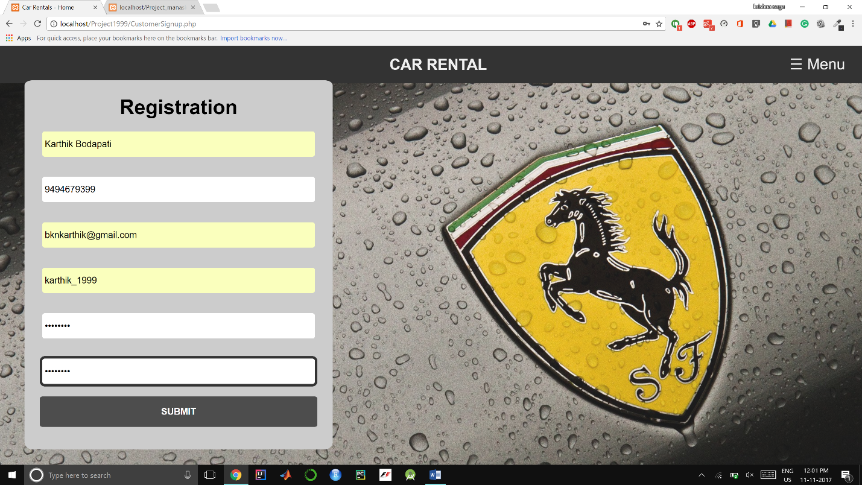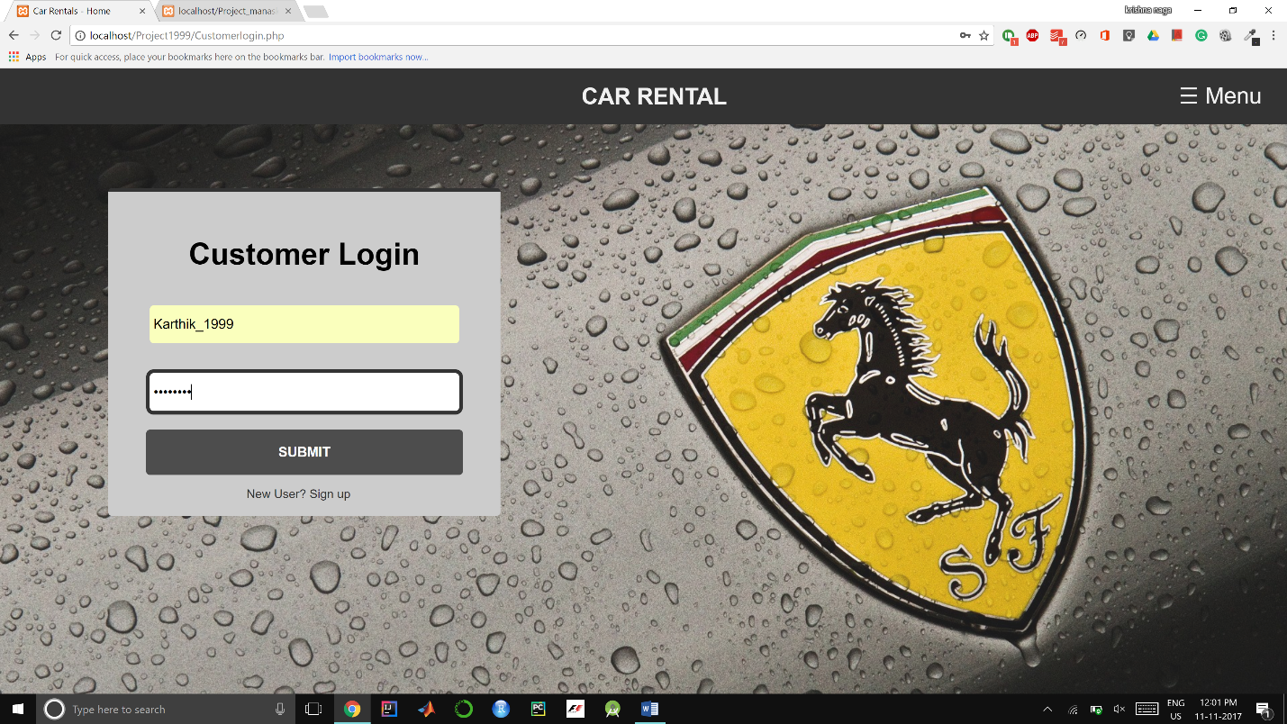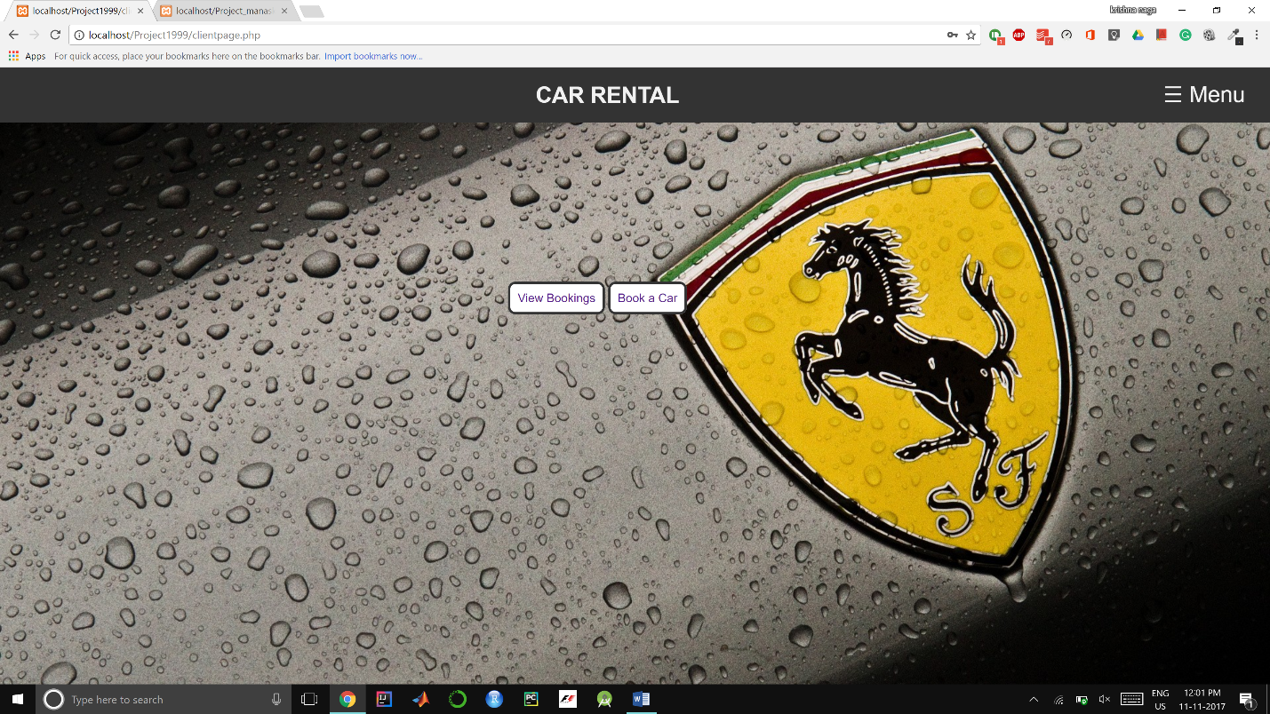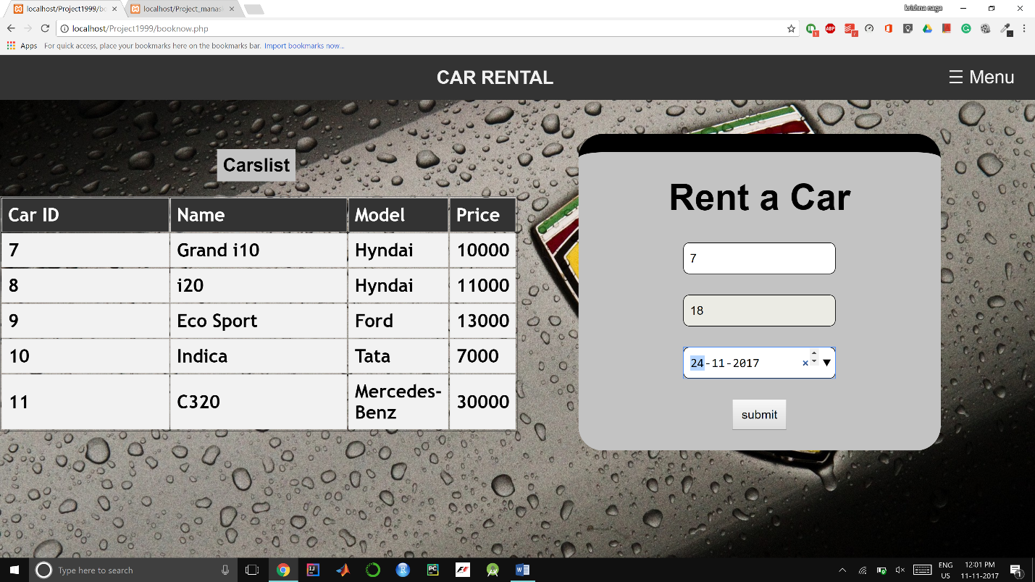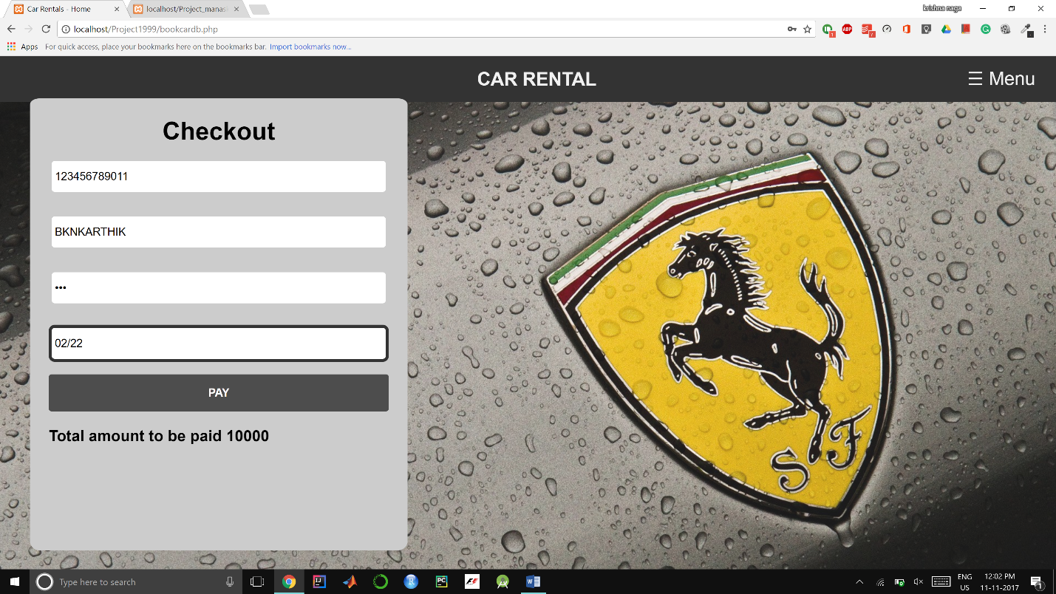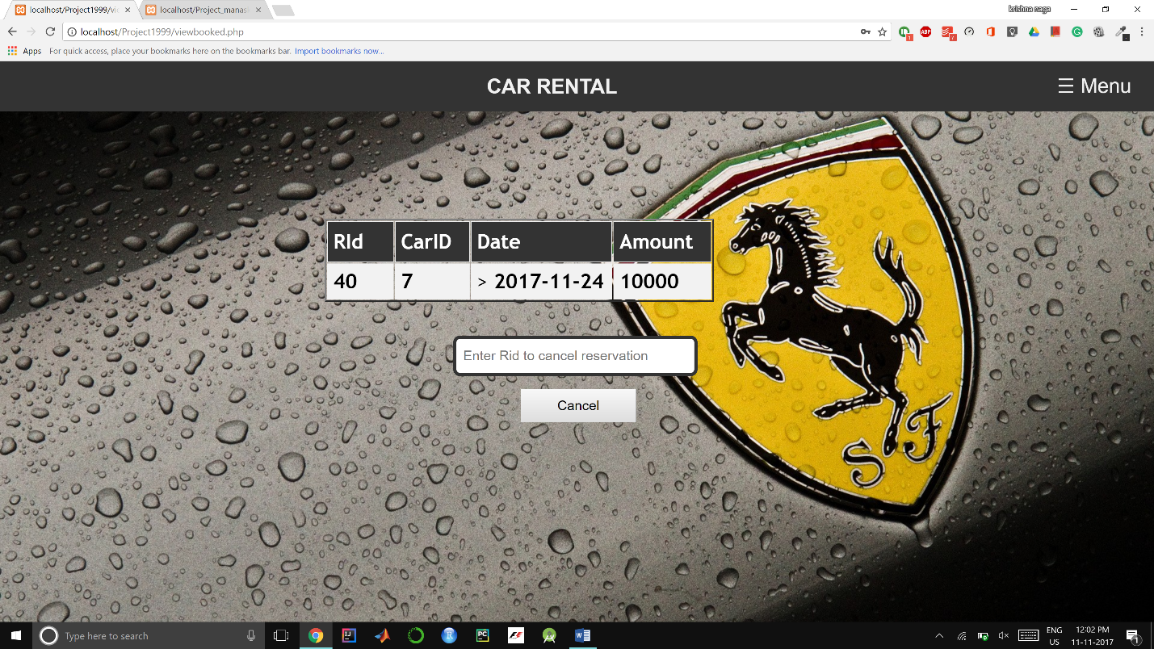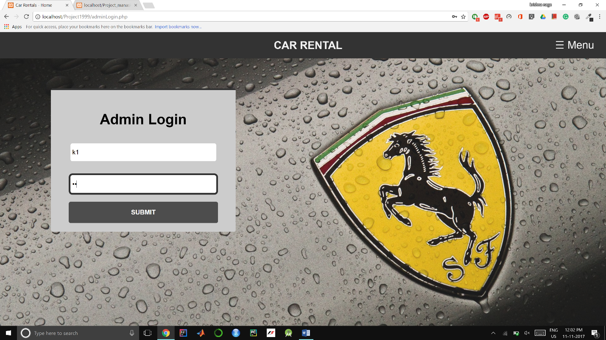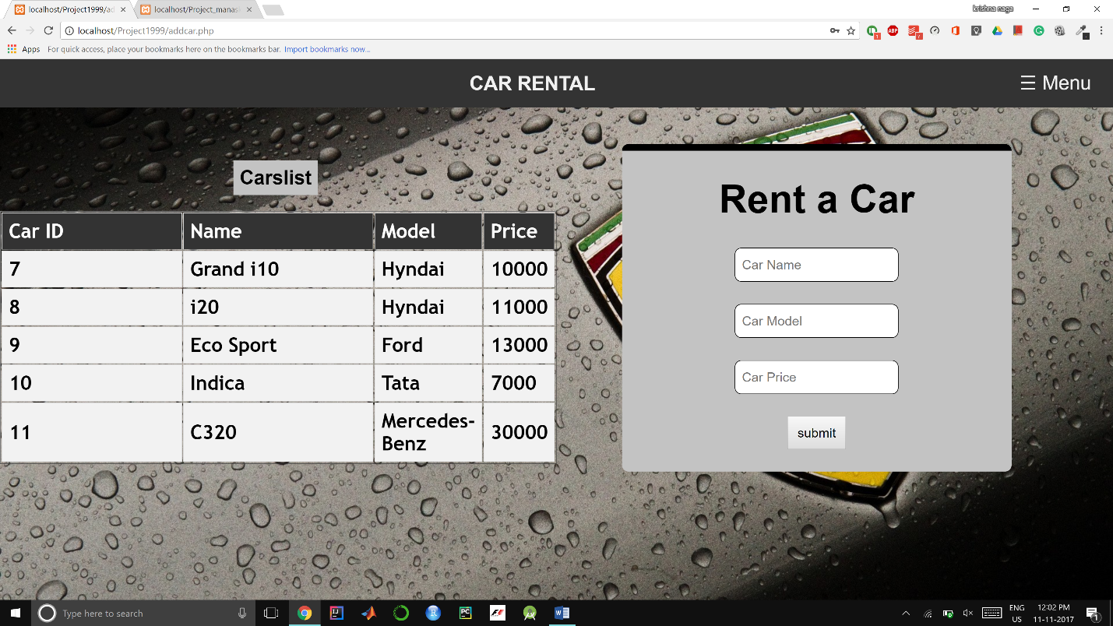

**CHAPTER 8**

**CONCLUSION**

To conclude the description about the project , The project, developed using PHP and MYSQL SERVER is based on the requirement specification of the user and the analysis of the existing system, with flexibility for future enhancement. CAR RENTAL MANAGEMENT SYSTEM is very useful for hostel allotment. This car rental managment software is designed for people who want to manage various activities in the hostel. For the past few years the numbers of educational institutions are increasing rapidly. Thereby the numbers of hostels are also increasing for the accommodation of the students studying in this institution. And hence there is a lot of strain on the person who are running the hostel and software’s are not usually used in this context. This particular project deals with the problems on managing a hostel and avoids the problems which occur when carried manually. Identification of the drawbacks of the existing system leads to the designing of computerized system that will be compatible to the existing system with the system which is more user friendly and more GUI oriented.

**CHAPTER 9**

**BIBLIOGRAPHY**

1. www.w3schools.com

2. in.php.net

3. en.wikipedia.org/wiki/PHP

4 . www.hotscripts.com/category/php/

5. [www.mysql.com/click.php?e=35050](http://www.mysql.com/click.php?e=35050)

6. **www.stackoverflow.com**